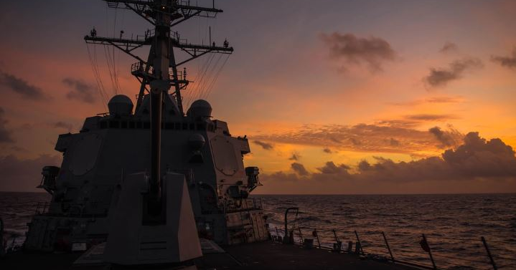
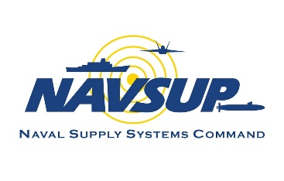
Supply Corps Team,
OP Monthly
February 2024

This month, we will focus on educational opportunities within the Supply Corps, bringing light the various opportunities available to our community. Higher education is important because it teaches us to think critically, strengthens our leader development processes, and enhances our capability to develop, generate, and employ naval forces worldwide.

We will also touch on the upcoming postgraduate education screening boards, discuss each of the service schools, provide updates to the Training with Industry program, share the policy change for official photos, and link information for the newly updated SWSCO instruction.

Thank you for everything that you do.

CAPT Alsandro H. (Jay) Turner
Director, Supply Corps Personnel

New and Noteworthy…

Graduate Education Spotlight
Overview
The Secretary of the Navy, the Honorable Carlos Del Torro, stated in June 2023, “…education is a critical warfighting enabler. We will continue to strengthen our Department’s culture, policies, processes, talent management, and investments to reflect education’s key role in force development.” The Navy values educational opportunities across all paygrades. Education enables Supply Corps officers to conduct critical research, develop strategic planning skills, enhance skillsets, and further the overall mission.

Within the Supply Corps, graduate education is a valued achievement, whether it be self- or Navy-funded. Review the It’s Your Education Playbook for more information about educational opportunities.

Click to learn more about the service colleges and PG curriculum for Supply Corps Officers. . .

Naval Postgraduate School
The Naval Postgraduate School (NPS) was established in 1909 in Annapolis, Maryland. It was originally a school of marine engineering. In 1912 the course list expanded to include ordnance and gunnery, electrical engineering, naval construction, and civil engineering. During WWII, Fleet Admiral Ernest King established a commission to review the role of graduate education in the Navy. In 1945, Congress passed legislation to make the school a fully-accredited, degree-granting, graduate institution. Two years later, the NPS moved to Monterey, California, on the grounds of the old Hotel Del Monte (now Herrmann Hall). Over time, NPS expanded the campus to accommodate the growing curricula, and in 2009, the school celebrated its centennial anniversary.

NPS has thirteen academic departments, ranging from applied undersea warfare to defense business management. The Supply Corps’ curricula are located in the Department of Defense Management (DDM) and Operations Research (OR).

Navy War College
The U.S. Naval War College (NWC), the oldest institution of its kind, was founded in 1884 by Rear Admiral Stephen B. Luce to better educate the Fleet. Rear Admiral Luce sought to combine the study of war with topics unfamiliar to most naval officers at the time, such as management, finance, planning and tactics, and international relations. They sought to link these disciplines through war gaming and analysis of political-military issues.

The NWC has seven colleges of practice: College of Leadership and Ethics, College of Maritime Operational Warfare, College of Naval Command & Staff (CNCS), College of Naval Warfare, Naval Command College, Naval Staff College, and College of Distance Learning. Mid-grade Supply Corps officers may attend the College of Naval Command and Staff (PG Code 681). By attending CNCS, students will earn their Joint Professional Military Education 1 (JPME-1), a Master of Arts in Defense and Strategic Studies, and the JPN AQD.

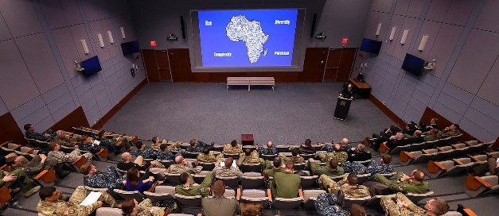
Maritime Advanced Warfighting School
Maritime Advanced Warfighting School (MAWS) is located at the NWC in Newport, Rhode Island (PG Code 680). Coursework is completed in conjunction with the College of Naval Command and Staff curriculum. MAWS develops strategic and operational leaders with the skills required to plan, execute, and assess combined, joint, and naval operations.

Officers take courses in decision-making, strategy and war, operational art, and doctrine, culminating in a capstone planning project. The program includes planning exercises, wargaming, and warfighting seminars. Students earn JMPE-1 credit, a master’s degree in Defense and Strategic Studies, and the JP1 AQD.
U.S. Army Command and General Staff College
The Army Command and General Staff College (CGSC) was established in 1881 as the School of Application for Infantry and Cavalry to develop and advance leaders for interagency and multinational operations. Throughout the 20th century, the CGSC curriculum expanded, to include lessons learned from past and current conflicts.

CGSC, located at Fort Leavenworth, Kansas, has four schools: the Command and General Staff School, School of Advanced Military Studies, School for Command Preparation, and School of Advanced Leadership and Tactics. Mid-grade Supply Corps officers may attend the Command and General Staff School (PG Code 682). Students earn JPME-1 credit, a Master of Military Arts and Science degree, and the JPN AQD.

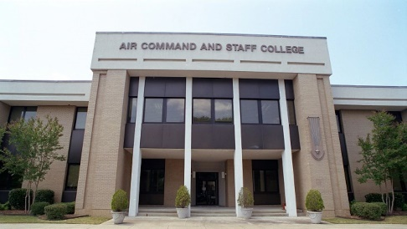
Air University
In the early 1930’s, the Army Air Corps Tactical School moved to Montgomery, Alabama and established Maxwell Field as the center for airpower education. In 1946, the Air University (AU) was established at Maxwell Field with the goal to educate planners and leaders in air and space power.

AU operates across four military installations, with course availability across all paygrades within the Air Force. Mid-grade Supply Corps officers may attend courses at the Air Command and Staff College (PG Code 683). Students take courses in the profession of arms, leadership, joint operations, airpower, and the international security environment. Students earn JPME-1 credit, a Master of Military Operational Art and Science degree, and the JPN AQD.

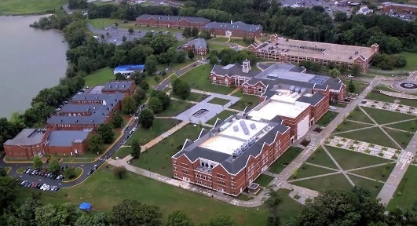
Marine Corps University
The Marine Corps University (MCU) was founded in 1989 by the Commandant of the Marine Corps, General Alfred M. Gray. It consolidated five independent Marine Corps schools into a single university. The university was established to shift the Marine Corps’ warfighting doctrine to one of ‘maneuver warfare,’ with a demand for leaders that think critically and act decisively.

MCU has six colleges and schools with nine programs, seven academic support elements, a history division, and a museum. Mid-grade Supply Corps officers attend courses at the U.S. Marine Corps Command and Staff College (PG Code 684), founded in 1920 as a Field Officer’s Course in Quantico, Virginia. The courses cover topics in leadership, warfighting, war studies, and security studies. Students analyze policy and doctrine, conflict, culture, operations, and ethical leadership practices. Students earn JPME-1 credit, a Master of Military Studies degree, and the JPN AQD.

Supply Corps Postgraduate Education Screening

The FY25 Supply Corps Postgraduate (PG) Education Screening Board (#302) convenes on 3 April 2024. This board automatically screens eligible candidates for Naval Postgraduate School (NPS) and all service colleges. In preparation for the board, Supply Corps officers in year groups 2016-2018 must ensure their records meet the minimum requirements (listed in the expanded link) to be eligible for postgraduate screening. Individuals who do not desire to be screened for a Navy-funded PG opportunity must contact the Supply Corps Career Counselor and request a PG preference “975” (do not select/do not pick) be placed into their record.

Click to see eligibility requirements for the FY25 PG screening board. . .

Minimum eligibility requirements:

- 3100-designated officer in Year Group 2016, 2017, or 2018
- Submitted PG School Preferences, as listed in Officer Data Card (ODC) Block 94
- Completed one operational tour (928 AQD), listed in ODC Block 72/Officer Summary Report (OSR) Special Qualifications
- Attained at least one warfare qualification (ODC Block 72/OSR Special Qualifications)
- Possess an Academic Profile Code (APC) of 345 or better (ODC Block 47) for NPS, CIVINS Program, and Naval War College*
- Not previously selected for and declined a PG opportunity

*If you do not meet the minimum APC requirement, you may request an APC Eligibility Waiver. Route the waiver to the Director, Office of Personnel via the Supply Corps Career Counselor. Requests for waiver must be received by 22 March 2024.

Officers selected for a Navy-funded PG opportunity will be slated based upon their preferences, performance, APC, and needs of the Navy. Selected officers are expected to execute orders to their slated PG opportunity.

Civilian Institutions Education Board
Officers are highly encouraged to submit a nomination package to be considered for the Civilian Institutions (CIVINS 810/811) program. The screening takes place during the PG Education Screening Board (#302). Note: 810 or 811 should not be listed as a PG Preference in Block 94 of your ODC. The nomination package serves as the preference indicator.

Officers selected for the 810 Program will receive a Master of Business Administration (MBA) from a quality civilian business school. Those selected for the 811 Program will attend the University of Kansas, earn an MBA from the School of Business and a graduate certificate in Petroleum Management from the School of Engineering.

Click to see more information about the CIVINS 810/811 programs. . .

The FY25 810 Schools

Carnegie Mellon University (Tepper) Columbia University

Cornell University (Johnson) Dartmouth College (Tuck)

Duke University (Fuqua) Emory University (Goizueta)

Georgetown University (McDonough) Georgia Institute of Technology (Scheller)

Harvard University Indiana University (Kelley)

Massachusetts Institute of Technology (Sloan) New York University (Stern)

Northwestern University (Kellogg) Rice University (Jones)

Stanford University University of California at Berkeley (Haas)

University of California Los Angeles (Anderson) University of Chicago (Booth)

University of Michigan (Ross) University of Notre Dame (Mendoza)

University of North Carolina at Chapel Hill (Kenan-Flagler) University of Pennsylvania (Wharton)

University of Rochester (Simon) University of Southern California (Marshall)

University of Texas at Austin (McCombs) University of Virginia (Darden)

University of Washington (Foster) Vanderbilt University (Owen)

Washington University at St. Louis (Olin) Yale University

Eligibility Requirements
- 3100-designated officer in Year Group 2016, 2017, or 2018
- Submit a nomination package, as a Letter to the Board, stating your preferred program (810, 811, or both – in order of preference)
- Complete one operational tour (928 AQD on ODC Block 72, OSR Special Qualifications)
- Possess at least one warfare qualification (ODC Block 72, OSR Special Qualifications)
- Possess an APC of 245 or better (ODC Block 47) for 810 or 333 or better for 811*
- Submit a GMAT/GRE Official Score Report

*If you do not meet the APC requirement, you may request an APC Eligibility Waiver. Route the waiver to the Director, Office of Personnel via the Supply Corps Career Counselor. Requests for waiver must be received by 22 March 2024.

Sample letters can be found on the Supply Corps’ MyNavy HR site and the eSUPPO app. Packages must be submitted via email to the Supply Corps Career Counselor and the ESSBD link on BOL. All packages to the Board President must be received by 22 March 2024.

Training With Industry Program
Training with Industry (TWI) is a 12-month program that provides participants with the opportunity to represent the Supply Corps at premier Fortune 500 corporations around the country, such as Starbucks (Seattle, WA), The Home Depot (Atlanta, GA), FedEx Express (Memphis, TN), and Exxon Mobil* (Houston, TX). Officers chosen by an annual Flag-led selection board will gain exposure to executive-level decision-making, expand their professional knowledge, and provide a conduit for logistics innovation between industry and the Supply Corps. The CY25 TWI Program board convenes on 15 April 2024.

Click to learn about the CY25 TWI board and updated eligibility criteria. . .

Eligibility Requirements
- 3100-designated LT or LCDR
- Completed or currently assigned to second operational tour (92A or 929 AQD)
- Complete a master’s degree no later than the CY following the TWI selection board
- Have a projected rotation date (PRD) between 1 December 2024 and 31 January 2026
- Have not completed a Navy-funded CIVINS (810) program
- *Exxon Mobil candidates
  - Must have experience in Petroleum, Oil, and Lubricants (POL) terminal operations in a Defense Fuel Support Point (DFSP) billet, or will earn that experience prior to their PRD
  - May have completed a Navy-funded CIVINS (811) program

An official letter to the board requesting to be screened is not required; however, officers may submit additional information for consideration by 1 April 2024. Officers who wish to decline screening must notify the Supply Corps Career Counselor no later than 1 April 2024.

Spring 2024 Internship Screening
NAVSUP OP is accepting packages for the spring 2024 internship screening! The deadline for submission is Friday, 29 March 2024. Program and billet list updates are available on the MyNavy HR Supply Corps Internship page.
Eligibility Requirements:
- 3100- or 6510-designated ENS, LTJG, or LT
- Earned bachelor’s degree
- Successful completion of (or will complete) one operational tour
- PRD between October 2024 and October 2025 (waivers accepted)

Note: LTs are only considered if participation will not affect their promotion opportunity to LCDR. For more information or to submit a package, contact the Internship Program Coordinator.

From the Career Counselor’s Desk
The requirement to have an official photograph in your record has been cancelled per MILPERSMAN 1070-180 (CH-85, NOV23).

If attempting to upload a photo to ESSBD, the below message will appear.

“ATTENTION:
This application is inactive. In compliance with the DoD Memorandum dated 14Jul2020, the officer photo will no longer be supplied to selection boards for consideration (command/promotion, etc.). With removal from the board review process, the photo is no longer required to be ingested into the officer's permanent record (OMPF). MILPERSMAN 1070-180, Officers Photographs, has also been canceled to comply with the DoD requirement.”

Surface Warfare Supply Corps Officer Instruction Update

The Surface Warfare Supply Corps Officer (SWSCO) Instruction has been updated to create a consistent board experience and align with Surface Warfare Officer community instructions. Notable changes include:

- The SWSCO qualification is now required to be earned within the first 18-months aboard
  - The Commanding Officer must notify CNSP N41 if there are any constraints that could preclude an officer from qualifying within this timeframe. Ensure OP is also notified of the qualification status.
- The participants of a SWSCO board are delineated based on platform size
- The Level of Knowledge subject areas are outlined within the enclosures

A link to the instruction, COMNAVSURFPAC/COMNAVSURFLANT INSTRUCTION 1412.6B, can be found on the Supply Corps’ MyNavy HR Instructions page (CAC Enabled). For questions, refer to your Type Commander (TYCOM) team.

Summer Quarter Course Opportunity from Naval Postgraduate School

Master of Science in Program Management (MSPM), Master of Science in Contract Management (MSCM), and the Master of Science in Financial Management (MSFM) are non-resident, part-time online graduate degree programs. These DoN-funded programs are for qualified active-duty military personnel, federal civilian employees, and defense contractors.

Students enroll in two courses each quarter for eight consecutive quarters over Zoom. Instruction is synchronous with live interaction between the professor and the students. This allows students to take classes while supporting the mission of their command/agency. Note: MSFM requires a one-week, in-person residency requirement at NPS in Monterey, CA, which includes an orientation and a graduate-level course.

Applications are accepted online through 1 April 2024. For any questions, contact Cheryl Southern, Acting Director of Admissions, at 831-521-2190 or admissions@nps.edu.

2024 Ruehlin Seminar

The Ruehlin Seminar is an Executive Transition Assistance Program (XTAP), which focuses on the practical aspects of career transition. The seminar is provided to senior officers, enlisted personnel (E8/E9), and Warrant Officers who have 20-30+ years on Active Duty and are planning to retire in the next two years. The course is intended for Active Duty Supply Corps personnel and their partners. Travel is self-funded by participants.

Click to see more information about the Ruehlin Seminar. . .

The tentative dates for the two seminars scheduled for FY 24 are:

1. Washington, DC 13-17 May 2024

2. San Diego, CA 5-9 August 2024

Due to limited seating, attendance requests should be submitted NLT six weeks from the seminar start date. If interested in attending an upcoming seminar, contact Ms. Lisa Mobius at lisa.e.mobius.civ@us.navy.mil. Note: The Ruehlin Seminar does not replace the required Transition Assistance Program (TAP) for officer and enlisted personnel separating/retiring from Active Duty.

2024 OP Roadshow

NAVSUP OP is hitting the road and heading your way! The OP Team will present valuable career information, discuss different facets of the Supply Corps community, and conduct one-on-one career interviews.

Note from the Navy Supply Corps Foundation (NSCF): Be sure to update contact information with the local Navy Supply Corps Foundation (NSCF) chapter to receive the latest and greatest information. NSCF chairs, feel free to reach out to the Supply Corps Career Counselor team for assistance to ensure all member information is up to date.

Click to see the 2024 OP Roadshow dates. . .

4 to 8 March Pacific Northwest / Naval Postgraduate School

18 to 22 March Norfolk / Little Creek

1 to 5 April Jacksonville / MacDill AFB

18 to 20 April Fort Worth (Reserve Component)

15 to 24 April Pearl Harbor / Guam

11 to 14 May Reserve Component Virtual

20 to 24 May Bahrain

3 to 7 June Groton / New England

10 to 11 June CONUS Virtual

12 June 6th Fleet Virtual

13 to 15 June 7th Fleet Virtual

*Schedule is subject to change.

Important Links

FY 25 Board Schedule

FY 25 Active Duty Promotion Selection Board Zone Message (NAVADMIN 290/23)

FY 25 Reserve Promotion Selection Board Zone Message (NAVADMIN 301/23)

Contact Us

Position | Name | E-mail
Director | CAPT Jay Turner | alsandro.h.turner2.mil@us.navy.mil
Director, Detailing Division | CAPT Dena Risley | dena.b.risley.mil@us.navy.mil
OP Assistant | CDR Travis Miller | travis.m.miller24.mil@us.navy.mil
OP1 Assistant | LCDR K. Matt Wall | kevin.m.wall10.mil@us.navy.mil
Reserve & TAR Director | CAPT Dave Davis | david.w.davis10.mil@us.navy.mil
TAR Mgt. Branch Detailer | CDR Treven Feleciano | treven.s.feleciano.mil@us.navy.mil
“Pit Boss”/LCDR Detailer | CDR Dustin Martindale | dustin.r.martindale.mil@us.navy.mil
LT Operational/PG School | LCDR Winston Lamb | winston.c.lamb.mil@us.navy.mil
LT Shore Detailer | LCDR Nicholas Mays | nicholas.c.mays.mil@us.navy.mil
CWO/BQC/Submarine Detailer | CWO5 Benny Brockington | benny.brockington.mil@us.navy.mil
AC Career Counselor | CDR Long Tran | long.k.tran.mil@us.navy.mil
RC Career Counselor | LCDR Bethany Satterwhite | bethany.c.satterwhite.mil@us.navy.mil
Accessions/Internship Officer | LT Lydia Sankey | lydia.j.sankey.mil@us.navy.mil
Director, Supply OCM | CDR Leanne Riley | leanne.r.riley.mil@us.navy.mil
Deputy, Supply OCM | Ms. Beth Schudel | beth.r.schudel.civ@us.navy.mil
Director, Reserve OCM | CDR Eric Gardner | eric.a.gardner5.mil@us.navy.mil

Supply Corps Officer Strength

3100 Active Component
Paygrade | Authorized | Inventory | Gross Over/Under | Non-Distributable Inventory | Total Delta
O-6 | 172 | 165 | -7 | 6 | -13
O-5 | 353 | 343 | -10 | 5 | -15
O-4 | 533 | 491 | -42 | 2 | -44
O-3 | 712 | 619 | -93 | 18 | -111
O-2 | 267 | 296 | 29 | 16 | 13
O-1 | 258 | 291 | 33 | 5 | 28
Totals | 2295 | 2205 | -90 | 52 | -142
Data source: the Officer Inventory / Authorization (Tri-Color) dated 31 Jan 2024.

Note: Officers selected for promotion in FY24 are listed in their current rank. Officers are detailed to billets in the next higher rank, resulting in lower distributable LT inventory numbers.

3107 Reserve Component –Training and Administration of the Reserves (TAR)
Paygrade | Authorized | Inventory | Delta
O-6 | 8 | 10 | 2
O-5 | 27 | 23 | -4
O-4 | 29 | 41 | 12
O-3 | 28 | 21 | -7
O-2 | 0 | 4 | 4
O-1 | 1 | 1 | 0
Totals | 93 | 100 | 7

3105 Reserve Component (RC) – Selected Reserves (SELRES)
Paygrade | Authorized | Inventory | Delta
O-6 | 52 | 50 | -2
O-5 | 175 | 171 | -4
O-4 | 316 | 299 | -17
O-3 | 176 | 141 | -35
O-2 | 82 | 46 | -36
O-1 | 25 | 77 | 52
Totals | 826 | 784 | -42

3165 RC In-Training
Paygrade | Authorized | Inventory
O-3 | 0 | 4
O-2 | 0 | 19
O-1 | 0 | 84
Totals | 0 | 107

6510 Limited Duty Officer (LDO)
Paygrade | Authorized | Inventory | Gross Over/Under | Non-Distributable Inventory | Total Delta
O-6 | 0 | 0 | 0 | 0 | 0
O-5 | 0 | 0 | 0 | 0 | 0
O-4 | 1 | 0 | -1 | 0 | -1
O-3 | 34 | 19 | -15 | 1 | -16
O-2 | 9 | 11 | 2 | 0 | 2
O-1 | 15 | 14 | -1 | 0 | -1
Totals | 59 | 44 | -15 | 1 | -16

7520 Food Service Warrant
Paygrade | Authorized | Inventory | Gross Over/Under | Non-Distributable Inventory | Total Delta
CWO-5 | 3 | 5 | 2 | 2 | 0
CWO-4 | 10 | 13 | 3 | 2 | 1
CWO-3 | 25 | 24 | -1 | 4 | -5
CWO-2 | 20 | 21 | 1 | 0 | 1
Totals | 58 | 63 | 5 | 8 | -3

Individual Augmentation (IA) Update

Currently there are 49 filled Supply Corps IA requirements*:

Active Component (3100, 6510, 7520): 13
Rank | Djibouti | Bahrain | Kuwait | Hawaii | Total
ENS
LTJG | 2 |  |  |  | 2
LT | 1 |  | 1 |  | 2
LCDR | 5 | 1 | 1 | 1 | 8
CDR |  |  | 1 |  | 1
CAPT
Total | 8 | 1 | 3 | 1 | 13

Reserve Component (3165, 3105, 3107): 36
Rank | Iraq | UAE | HOA | Bahrain | Kuwait | Germany | Korea | Hawaii | Guam | CONUS | Total
ENS
LTJG |  |  | 3 |  |  |  |  |  | 1 |  | 4
LT |  | 1 | 5 | 2 |  |  | 1 |  | 2 | 1 | 12
LCDR | 2 |  | 2 | 5 | 1 | 5 |  |  |  | 1 | 16
CDR |  |  | 1 |  | 1 |  |  | 1 | 1 |  | 4
CAPT
Total | 2 | 1 | 11 | 7 | 2 | 5 | 1 | 1 | 4 | 2 | 36

*Data pulled 26 September 2023 from Individual Augmentation Portal represents count of Boots on Ground (BOG) at time of data pull.

NOTE: Mobilizations, IAs, and GSAs range from 6-12 months. Once assigned, GSA opportunities are updated and posted to Supply Corps’ GSA Detailer page on MyNavy HR and the eSUPPO app via Billets > TAR/GSA function.

